Europe’s fun sports and great sports people

LESSON PLAN

Module 15 “Europe’s fun sports and great sports people”

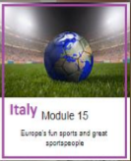

Topic: “ORIGINS OF SPORTS GAMES”

Teachers: Italian team

Time: 12 hours

Recipients: Second Classes Secondary School of 1st degree I.C."Herodoto"

Aims

The students will:
• Know the origins of sport games
• Compare team games with individual games
• Identify the games played in the various EU countries.

Expected results
-to observe the particularities of the different sport games of Europe
-to describe some elements of various european sport games
-to explain in their ownwords team games and individual games in Europe.

Teaching methods
Frontal, group and work in pairs, method of speech, demonstrative, method of research, work with text and illustrative method, leaning games (kahoot).

Materials
- Books, pictures, computer – presentations, posters, photos, brochures, markers, colours, glue, scissors, board.
- projector, screen
- speakers
- laptop or computer with the Internet connection
- tablets with QR scanners
- worksheets
Stage 1: INTRODUCTION
- Discussion about the detection of sport games in Europe :
• Research for the origins of sports games
• Discussion on the difference between team and individual games
• Study of the origins of the Olympics
• Identification of the most widespread and practiced sports all over the world
• Identification of the major Italian and European competitions in relation to FIFA and UEFA
www.treccani.it/enciclopedia/glossario-dei-simboli-olimpici_%28Enciclopedia-dello-Sport%29/
https://it.wikipedia.org/wiki/Fiamma_olimpica
www.tibursuperbum.it/ita/note/greci/OriginiOlimpiadi.htm
https://cultura.biografieonline.it/olimpiadi-dalleta-antica-ai-primi-giochi-olimpici-moderni/

https://www.skuola.net/educazione-motoria-medie/sport-individuali.html
https://europa.eu/european-union/topics/sport_it
Stage 2: PRESENTATION
The symbols of the different Olympic competitions: the Olympic flag, the Olympic card, the Olympic ceremony, the Olympic anthem, the Olympic medals, the Olympic message, the Olympic motto and the Olympic movement.

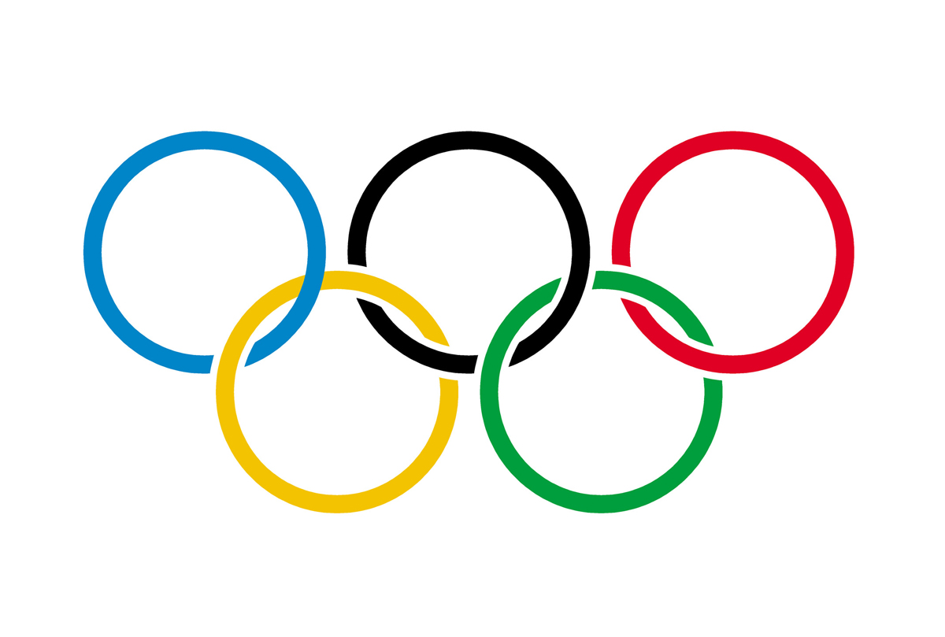

The Olympic flag
The symbol that dominates the Olympic flag is characterized by five colored circles: blue, black, red, yellow and green on a white background. These refer to the 5 continents therefore represents the universality of the games.
Olympic charter
Fix the principles and rules for the celebration of the Olympics.

Olympic ceremony
The most important ceremonies are: opening, closing and awarding of prizes. Feature the Olympic flame.
Olympic anthem
It was performed for the first time on the occasion of the opening ceremony of the I edition of the Olympic Games in Athens, in 1896.
Olympic medals
They are the main prizes awarded to the athletes who are placed in the first three places: gold, silver and bronze medal.
Olympic motto
"Citius !, Altius !, Fortius!" Is the Latin expression which means: "Faster, higher, stronger!"
Olympic Message
This officially became the Olympic message: "The important thing in the Olympics is not to win, but to participate; the essential thing is not to assert itself, but to fight well ".
Olympic Movement
The activity of the movement is permanent and universal and contributes to the construction of a better and peaceful world, without discrimination of any kind in a spirit of friendship, solidarity and fair play.

STAGE 3: GROUPWORK
a) Divide classes into groups
b) Name a leader who will report the answer after consulting all the members
c) The groups will be given a fixed time of three minutes to consult and report the answer

STAGE 4: CONSOLIDATION
In the end the boys will realize the symbols of the Olympic games.

TASK 1:

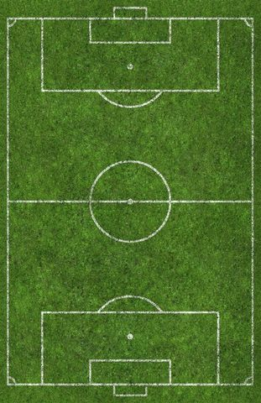

TASK 2:

Wizz Khaoot

https://play.kahoot.it/#/k/ad9ca093-a7d6-4f3a-92d4-750091f7eb3b

Author:
Italian team

